## Menu page

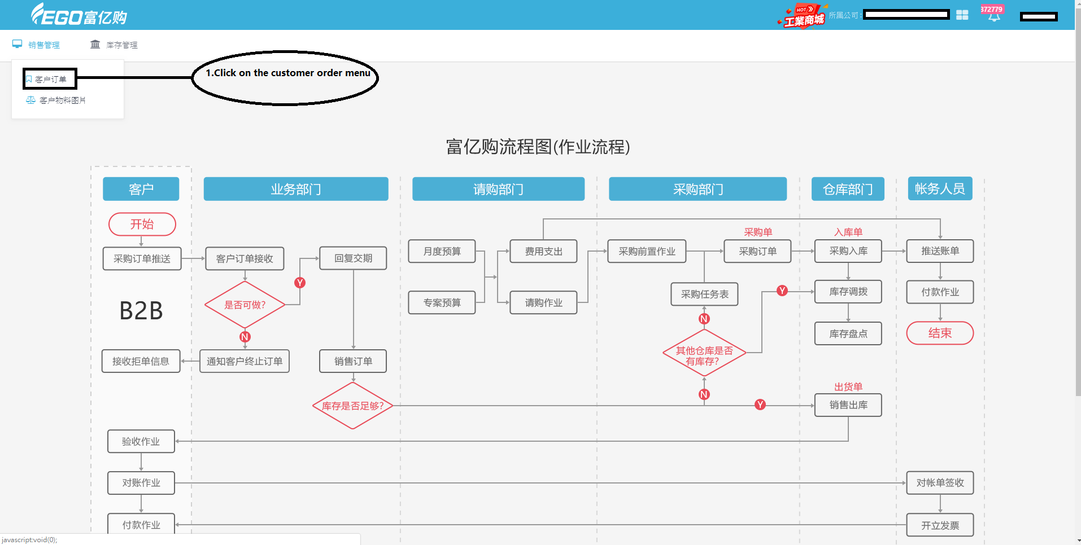

## 2、Purchase order shipment

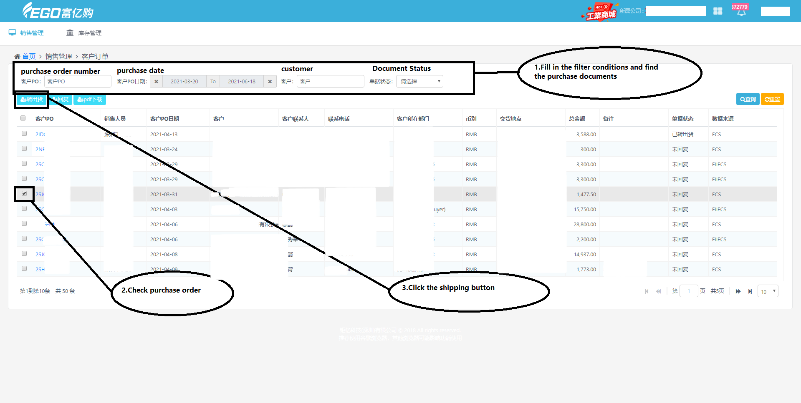

## 3、Shipping order confirmation

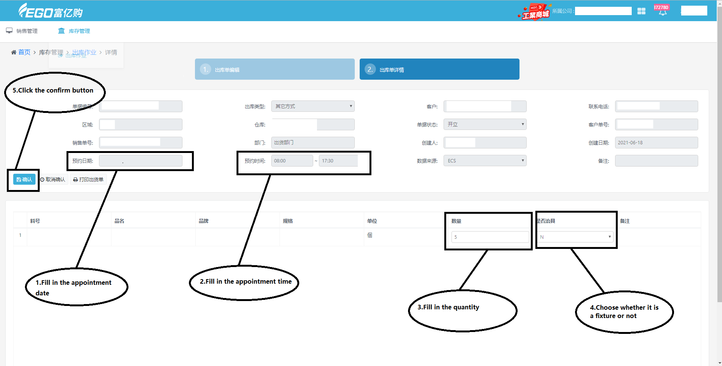

## 4、Fill in fixture number(It’s not a fixture ,you don’t have to fill it in)

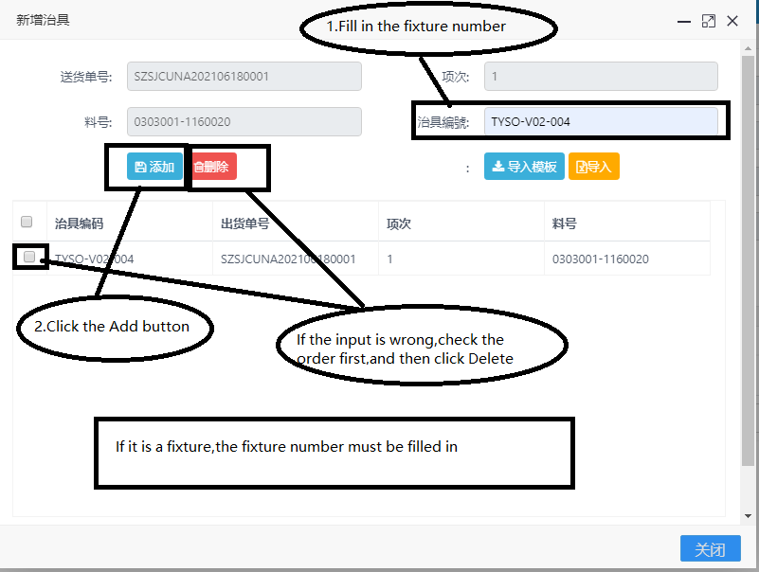

## 5、Print shipping order

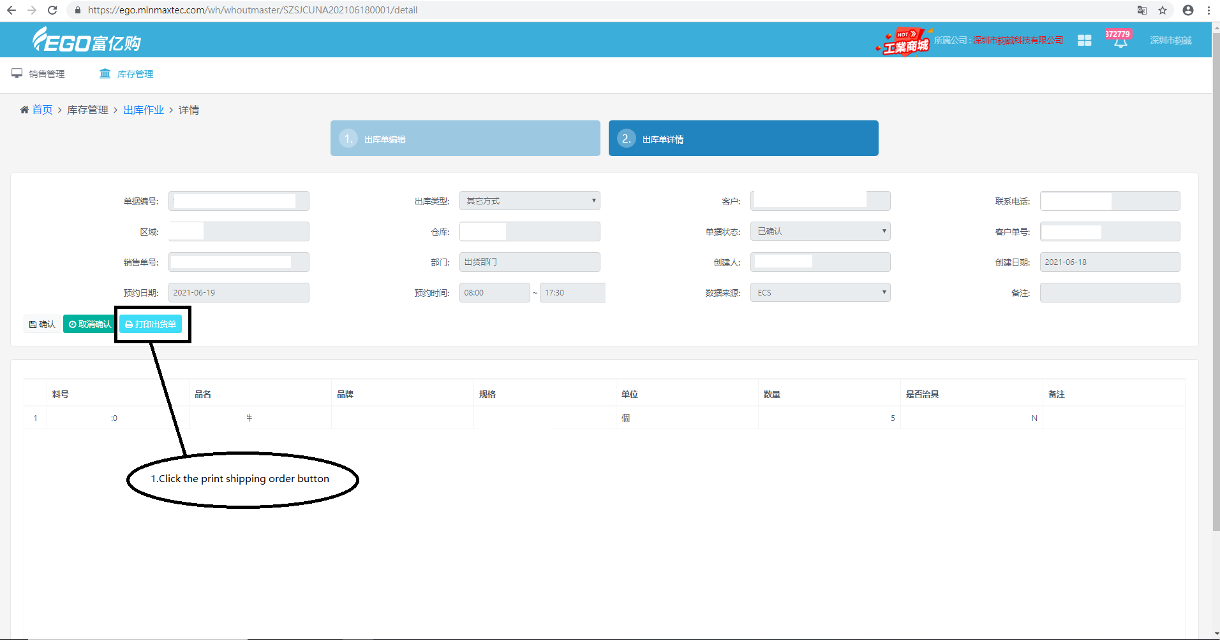

## 6、Shipping order and delivery QR code

